Distance Metrics and the Euclidean Algorithm
Euclidean · Manhattan · Minkowski
A Comprehensive Research Paper
Based on: The Euclidean Algorithm, Manhattan Distance & Minkowski's Theorem
June 2025

Abstract
This paper provides a unified academic review of three foundational mathematical topics: (1) the Euclidean Algorithm for computing the Greatest Common Divisor (GCD) of integers, (2) Manhattan Distance (L¹ metric) as a practical grid-based distance measure, and (3) the Minkowski Distance (Lᵖ metric) as a general framework that unifies both. We examine their historical origins, mathematical proofs, computational methods, and modern applications in machine learning, cryptography, and optimization. Each topic is supported by worked examples, visual diagrams, and comparison tables. The paper concludes that Euclidean (p=2) and Manhattan (p=1) are special cases of the Minkowski metric, providing a coherent theoretical framework.

1. Introduction
Mathematics provides elegant tools for measuring relationships between numbers and points in space. Three of the most important such tools are the Euclidean Algorithm, Manhattan Distance, and Minkowski Distance. Though developed centuries apart, they share a common theoretical foundation rooted in the concept of distance and divisibility [1,2].
The Euclidean Algorithm, dating to ~300 BC, computes the Greatest Common Divisor (GCD) of two integers using repeated division — a process that terminates in O(log n) steps. Manhattan and Minkowski distances, formalized in the 19th and 20th centuries, measure geometric distance in n-dimensional space under different norms. Together, these three concepts underpin number theory, machine learning, and applied mathematics [1,3].

2. The Euclidean Algorithm

2.1 Historical Background
The Euclidean Algorithm is one of the oldest known algorithms in mathematics. It was described by Euclid (~300 BC) in his work "Elements," Books VII and X, though it likely predates Euclid, possibly originating with the Pythagoreans or Theaetetus. Indian astronomer Aryabhata (5th century AD) used it as the "pulverizer" (kuttaka) for solving Diophantine equations. In 1844, Gabriel Lamé proved that its worst-case complexity is bounded by Fibonacci numbers, making it the first algorithm to have its complexity formally analyzed [1,4].

2.2 Core Principle
The algorithm exploits the key identity:

Key Identity | gcd(a, b) = gcd(b, a mod b)

This identity states that the GCD of a and b equals the GCD of b and the remainder when a is divided by b. By repeatedly applying this, the problem reduces until the remainder becomes zero.

2.3 Worked Example: gcd(1071, 462)
We trace through the algorithm step by step:

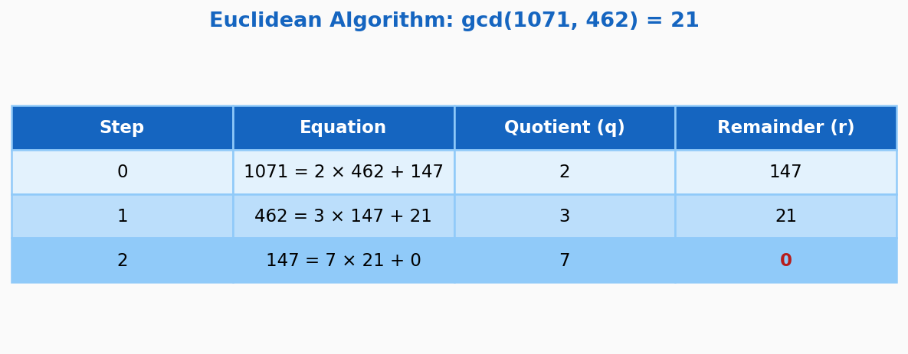
Figure 1: Step-by-step trace of the Euclidean Algorithm for gcd(1071, 462) = 21

2.4 Algorithm Flowchart
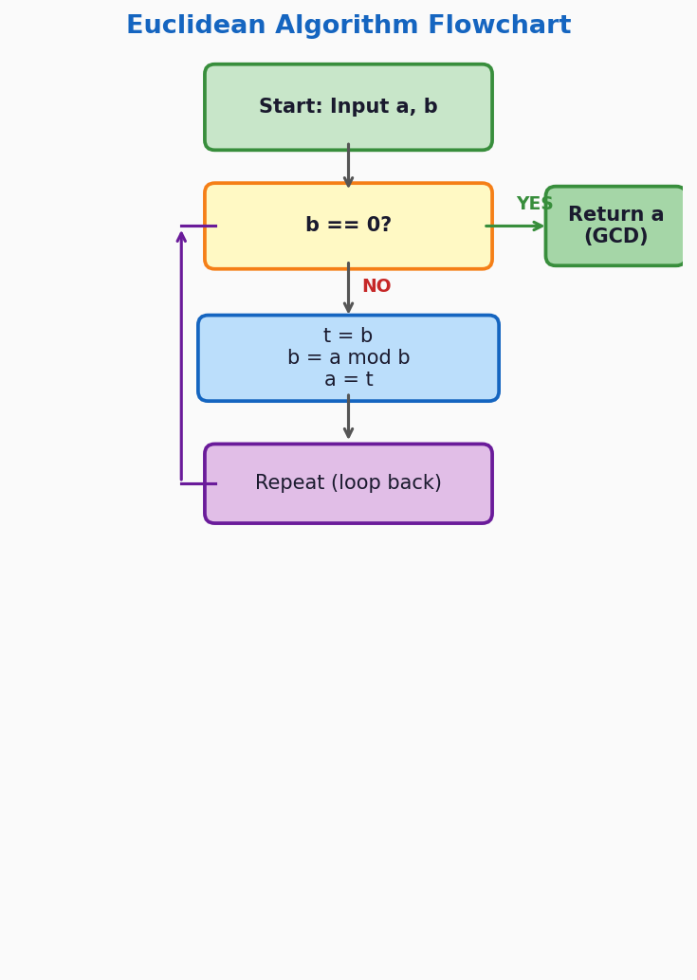
Figure 2: Flowchart of the iterative Euclidean Algorithm

2.5 Implementation
Pseudocode: function gcd(a, b): while b ≠ 0: temp = b; b = a mod b; a = temp return a → Complexity: O(log min(a,b))

2.6 Proof of Correctness & Termination
Termination: The remainders form a strictly decreasing sequence of non-negative integers: r₀ > r₁ > r₂ > ... ≥ 0. Since no infinite strictly decreasing sequence of natural numbers exists, the algorithm must terminate [1].
Correctness: At termination, rₙ₋₁ divides all prior remainders by back-substitution, and thus divides both a and b. Moreover, any common divisor of a and b must also divide all remainders. Therefore rₙ₋₁ = gcd(a,b) [5].

2.7 Extended Euclidean Algorithm
The extended version finds integers s, t (Bézout coefficients) such that:
Bézout's Identity | gcd(a,b) = s·a + t·b

This is critical in RSA cryptography for computing modular inverses, in the Chinese Remainder Theorem, and in solving linear Diophantine equations ax + by = c [1,8].

2.8 Complexity Analysis
Lamé's Theorem (1844) bounds the number of steps: for b < 10^d, the algorithm takes at most 1.44·d steps, i.e., the number of steps is O(log b). The worst case occurs when a and b are consecutive Fibonacci numbers. Modern binary GCD variants eliminate division for faster computation on hardware [7,9].

2.9 Applications
- Fraction simplification: gcd used to reduce numerator/denominator
- RSA cryptography: computing modular inverses via extended algorithm
- Chinese Remainder Theorem: solving simultaneous congruences
- Polynomial GCDs and error-correcting codes
- Abstract algebra: defines Euclidean domains (Gaussian integers, polynomials)

3. Manhattan Distance (L¹ Metric)

3.1 Historical Background
Roger Boscovich first used the L¹ norm in 1757 for regression analysis. Hermann Minkowski and Frigyes Riesz formally studied Lᵖ spaces around 1910 in the context of non-Euclidean geometries. Karl Menger coined the term "taxicab geometry" in 1952 for public education purposes. The name "Manhattan distance" comes from the grid-like street layout of Manhattan, New York, where you can only travel along axes — no diagonal shortcuts [1,2].

3.2 Definition & Formula
Manhattan (L¹) | d₁(x,y) = Σᵢ |xᵢ - yᵢ|

For two 2D points (x₁,y₁) and (x₂,y₂): d = |x₁-x₂| + |y₁-y₂|
Example: from (1,2) to (4,6): d = |1-4| + |2-6| = 3 + 4 = 7

3.3 Metric Properties (Proof Sketch)
- Non-negativity: |xᵢ - yᵢ| ≥ 0 always; equals 0 iff x = y
- Symmetry: |xᵢ - yᵢ| = |yᵢ - xᵢ| for all i
- Triangle inequality: |xᵢ - zᵢ| ≤ |xᵢ - yᵢ| + |yᵢ - zᵢ| by standard absolute value property [5]

3.4 Geometry: The "Taxicab Circle"
Under Manhattan distance, the set of points equidistant from the origin is a rotated square (diamond), not a round circle. The "circumference" of a unit diamond is 8 (compared to 2π ≈ 6.28 in Euclidean geometry), giving a "π analog" of 4 for taxicab geometry [2].

3.5 Applications
- A* pathfinding: Manhattan distance as heuristic for grid-based maps and games
- k-NN classification: more robust to outliers than Euclidean in high dimensions
- LASSO regression: L¹ penalty promotes sparsity in coefficients
- Compressed sensing: sparse signal recovery via L¹ minimization
- Bioinformatics: RNA sequence analysis and gene expression comparison [7,8]

4. Minkowski Distance (Lᵖ Metric)

4.1 Historical Background
Hermann Minkowski introduced the Lᵖ space framework in 1910 as part of his work on functional analysis and the geometry of numbers. The Minkowski metric generalizes both Euclidean and Manhattan distances under a single parameterized formula controlled by p. His theorem on lattice points (1896) established the field of "geometry of numbers," connecting continuous geometry with discrete arithmetic [2,3].

4.2 General Formula
Minkowski (Lᵖ) | dₚ(x,y) = (Σᵢ |xᵢ - yᵢ|ᵖ)^(1/p)

Special cases:
- p = 1 → Manhattan distance (diamond unit ball)
- p = 2 → Euclidean distance (circular unit ball)
- p → ∞ → Chebyshev distance (square unit ball, max coordinate difference)

4.3 Visual Comparison of Unit Balls
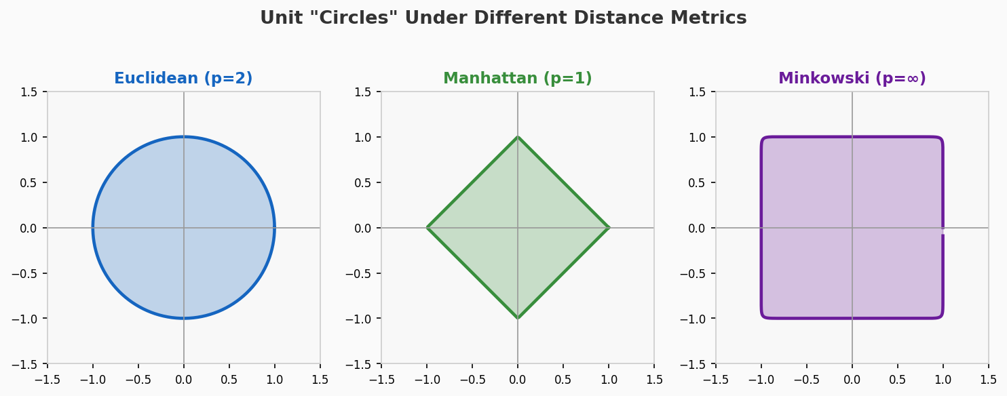
Figure 3: Unit "circles" under Euclidean (p=2), Manhattan (p=1), and Minkowski (p→∞)

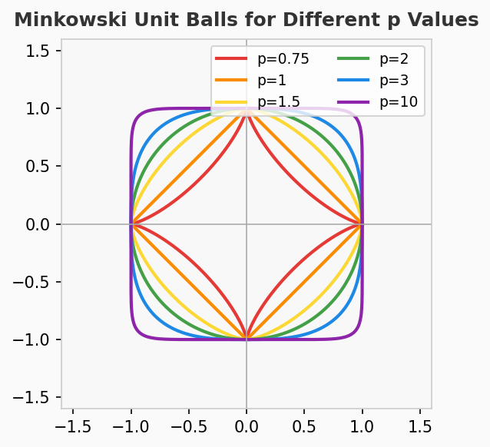
Figure 4: Minkowski unit balls for p = 0.75, 1, 1.5, 2, 3, and 10

4.4 Distance Comparison Chart
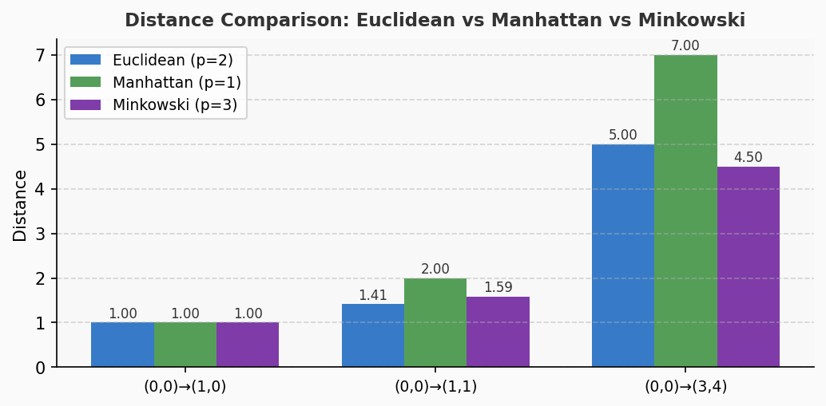
Figure 5: Numerical comparison of Euclidean, Manhattan, and Minkowski (p=3) distances for selected point pairs

4.5 Minkowski's Lattice Theorem
Theorem (Minkowski, 1896): Any centrally symmetric convex set S in ℝⁿ with volume greater than 2ⁿ · det(L) contains a non-zero integer lattice point. This bridges continuous geometry with discrete arithmetic [3].

Applications of the lattice theorem:
- Proof of Lagrange's four-squares theorem
- Finiteness of ideal class groups in algebraic number theory
- Dirichlet's unit theorem
- Lattice-based cryptography (post-quantum hardness assumptions) [3]

5. Comparative Analysis

5.1 Unified Summary Table
Aspect | Euclidean (p=2) | Manhattan (p=1) | Minkowski (general p)
Formula | √(Σ(xᵢ-yᵢ)²) | Σ|xᵢ-yᵢ| | (Σ|xᵢ-yᵢ|ᵖ)^(1/p)
Geometry | Round circles | Diamond shapes | p<2: diamond; p>2: square-like
Path model | Straight line | Grid / streets | Tunable parameter
Sensitivity | Quadratic (outliers amplify) | Linear (robust) | p controls sensitivity
Example (0,0)→(3,4) | 5.0 | 7 (3+4) | p=1:7 | p=2:5 | p=∞:4
Best for | Physics, images | Grids, sparse data, k-NN | Flexible experiments

Table 1: Comprehensive comparison of Euclidean, Manhattan, and Minkowski metrics

5.2 When to Use Each Metric
Euclidean (p=2): Best for continuous, isotropic spaces — physics simulations, image pixel distances, geometry. Assumes that diagonal movement is possible and meaningful.
Manhattan (p=1): Best for grid-constrained problems — urban navigation, k-NN with outlier robustness, LASSO regression, high-dimensional sparse data where most coordinates differ minimally.
Minkowski (general p): Used when the optimal p is unknown and must be tuned as a hyperparameter. Provides a flexible framework for experiments in machine learning and data mining [1,2].

5.3 Key Insight
Unifying Principle: Euclidean distance is Minkowski with p=2. Manhattan distance is Minkowski with p=1. The Minkowski family provides a continuous spectrum of distance metrics controlled by a single parameter p, making it the most general and flexible framework among the three.

6. Conclusion
This paper has presented a comprehensive and unified study of three foundational mathematical concepts: the Euclidean Algorithm, Manhattan Distance, and Minkowski Distance. The Euclidean Algorithm, despite its 2,300-year history, remains the gold standard for computing GCDs with provably optimal O(log n) complexity. Manhattan distance provides a practical and robust metric for grid-based and high-dimensional problems. Minkowski distance unifies both under a single parameterized framework, offering flexibility for both theoretical analysis and practical machine learning applications.
Together, these three tools exemplify the elegance of mathematics: ancient algorithms remain computationally optimal, geometric intuitions from taxicab geometry power modern AI search algorithms, and abstract algebraic theorems underpin post-quantum cryptography. Understanding their relationships deepens appreciation for the unity underlying apparently distinct areas of mathematics.

References
[1] Wikipedia Contributors. "Euclidean algorithm." Wikipedia, The Free Encyclopedia, 2025.
[2] Wikipedia Contributors. "Taxicab geometry." Wikipedia, The Free Encyclopedia, 2025.
[3] Encyclopedia of Mathematics Editors. "Minkowski theorem." Encyclopaedia of Mathematics, Springer, 2025.
[4] MathWorld — Weisstein, E.W.. "Euclidean Algorithm." MathWorld — Wolfram Web Resource, 2025.
[5] ProofWiki Contributors. "Euclidean Algorithm — Proof of Termination." ProofWiki.org, 2025.
[6] Purdue University, Dept. of Computer Science. "Proof that the Euclidean Algorithm Works." Purdue CS Technical Notes, 2024.
[7] GeeksforGeeks Editors. "Time Complexity of Euclidean Algorithm." GeeksforGeeks DSA Portal, 2025.
[8] KU Leuven Library. "Applications of the Euclidean Algorithm in Number Theory." LIRIAS Repository, 2023.
[9] GeeksforGeeks Editors. "Time Complexity of Euclidean Algorithm — Extended." GeeksforGeeks DSA Portal, 2025.
[10] KDnuggets. "Distance Metrics: Euclidean, Manhattan, Minkowski." KDnuggets Data Science Blog, 2023.
[11] Wikipedia Contributors. "Minkowski distance." Wikipedia, The Free Encyclopedia, 2025.
[12] Cassels, J.W.S.. "An Introduction to the Geometry of Numbers." Springer-Verlag, Berlin, 1959.
[13] Lamé, Gabriel. "Note sur la limite du nombre des divisions dans la recherche du plus grand commun diviseur." Comptes Rendus de l'Académie des Sciences, Vol. 19, 1844.
[14] Krause, Eugene F.. "Taxicab Geometry: An Adventure in Non-Euclidean Geometry." Dover Publications, 1986.

